RJTech

Reports Page Proposal

STATUS  Proposed |  | OWNER  RJTech project |  | LAST UPDATED  September 6, 2026

Prepared for | RJTech project team
Prepared by | Codex
Related files | Reports Page Concept.png; Reports Implementation Plan.md
Scope | Report functionality, sample interface, data rules, and build milestones

1 Recommendation
Build Reports as a place to investigate activity, reconcile totals, and export a chosen period. The Dashboard remains a quick overview; Reports adds detailed filters, explicit metric definitions, transaction drilldowns, and downloadable results. Start with Sales Orders, then extend the same layout to five related report areas.
Keep order value, money received, and outstanding balances separate. Each measures a different event or state. Use purchase dates for orders, payment dates for recorded receipts, and a clearly labelled current snapshot for inventory and outstanding balances. This is a design proposal only; no application implementation is included.

2 Scope
Initial release | Later data improvements
Sales Orders, with purchase-date totals and item details | Complete collections ledger including refunds
Recorded installment receipts and current balances | Historical balance snapshots and precise overdue aging
Current inventory, delivery history, customer activity | Stock movement ledger and purchase-cost valuation
Consistent filters, CSV, print, and light or dark mode | Saved presets, native XLSX, and generated PDF

3 Findings from the Current Project
The project already stores checkouts and their item prices, installment contracts and payments, delivery quantities, products, categories, and customers. These records support useful operational reports. However, a completed installment changes its checkout to Paid while retaining the original purchase date, so the existing paid-only Dashboard total is not cash collected during that period.
There is no complete payment ledger for full payments, down payments, and refund payouts. Products hold selling prices, not purchase costs, and inventory has no complete historical movement ledger. Start with reports these records can support and clearly state when a result reflects current status.

4 Sample Design and Report Areas

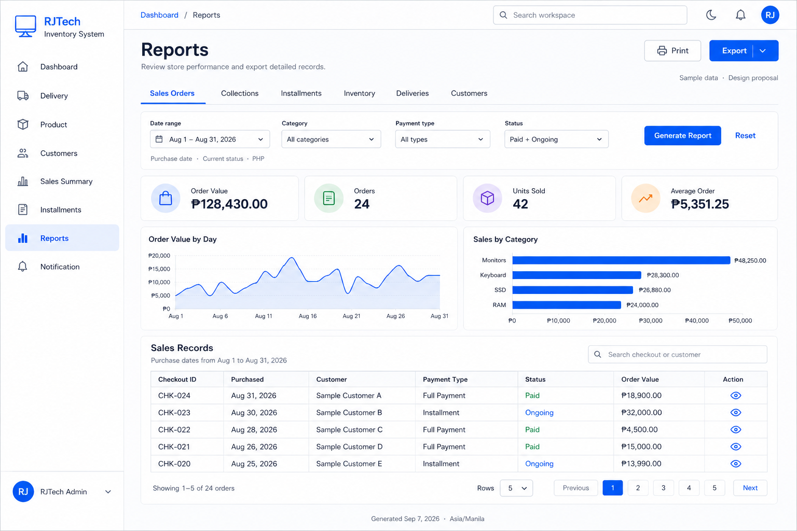
Figure 1. Reports page concept with fictional sample data. Open the accompanying PNG for full-size inspection; chart values illustrate layout.

Recommended report tabs

Report area | Main question | Date basis | Key output
Sales Orders | What was purchased? | Purchase date | Value, orders, units
Collections | Which receipts were recorded? | Payment date | Installment receipts
Installments | What is still owed? | Current snapshot | Open and overdue plans
Inventory | What needs restocking? | Current snapshot | Stock and reorder list
Deliveries | What stock arrived? | Delivery date | Batches and quantities
Customers | Who purchased in this period? | Purchase date | Customer activity

5 How the Page Works
- Choose a report tab. Sales Orders opens with the current month and Paid plus Ongoing orders selected.
- Choose a date preset or custom range, then relevant category, payment type, payment method, status, or customer filters. Only show filters supported by that report.
- Select Generate Report to apply edits. Reset restores that tab’s defaults. Show applied filters, date basis, PHP currency, and the generation time above the results.
- Read four summary cards, useful charts, and a detailed table. Search and sort the result; paginate the table while keeping totals over all matching records.
- Open an existing checkout, product, delivery, or installment details page from its formatted code or View action. Preserve filters when returning.
- Export all matching rows to CSV, or Print a clean report that can be saved as PDF. Export and print use the same applied filters and metric rules as the screen.
- Use existing light and dark theme tokens, blue actions, rounded cards, and table spacing. Keep status labels without dots, omit checkboxes and trend columns, and provide keyboard focus, loading, empty, and error states.

6 Implementation Boundaries
- Keep report requests read-only. Some installment display services update stored statuses; use dedicated queries and pure overdue calculations instead of invoking those write paths.
- Reuse the project’s details routes, code formatters, navigation, theme, and table patterns. Support small screens with stacked cards, scrollable tabs, and tables that retain readable columns.
- Use a shared report filter model and query service. Project only needed fields, aggregate in SQL, use AsNoTracking, and page detailed rows on the server.
- Apply the application’s access rules to both previews and exports. Customer contact details are optional columns; ordinary activity reports need only the customer name and reference.
- Add XLSX, saved presets, audited refund events, payment reconciliation, cost-based profit, and historical inventory only in later phases with the required records and agreed definitions.

7 Metric and Date Definitions

Rules shared by cards charts tables and exports

Metric | Source | Scope | Calculation or rule
Order Value | Checkout | Purchase period | Sum eligible order totals once; Paid + Ongoing by default
Orders and Units | Checkout items | Same filters | Distinct checkout IDs; sum ItemQuantity
Average Order | Order totals | Same filters | Order Value / Orders; show zero when there are no orders
Recorded Receipts | Installment payments | Payment period | Sum Paid payment amounts; excludes down payments
Outstanding | Installment balance | Current open plans | Sum Balance on eligible open plans; includes contract interest
Inventory Units | Product quantity | Current products | Sum quantities; classify low stock with existing reorder rules
Customer Activity | Checkout customer | Purchase period | Distinct transacting customers; no registration growth metric

Calculation safeguards

- A checkout containing several items counts as one order. Sum item quantities for units and stored CheckoutItem.SubTotal for item revenue; never multiply header totals through an item join.
- A category filter includes only matching item value and units. Count distinct orders containing those items and relabel value columns as Matching Item Value; do not show the whole checkout total as filtered category revenue.
- Keep merchandise order value separate from installment interest and payment receipts. Example: a PHP 10,000 order counts once; a PHP 1,000 later receipt belongs to its payment date. Remaining balance comes from the installment contract.
- Use current product categories as classifications and stored checkout item prices for historical values. Category edits may regroup past sales; preserve category snapshots later if historical classification is required.
Date ranges include the entire selected final day. Confirm how existing DateTime.Now records map to Asia/Manila before adding timezone conversions.

8 Consistency and Historical Limits
Every result must state its date basis and status scope. Current checkout statuses can restate earlier purchase periods after a cancellation or refund. Current inventory and balances are snapshots at generation time; they cannot be labelled month-end historical balances without additional records.
Scenario | Required behavior | Why it matters
Installment completes later | Order stays in its purchase period; receipt uses payment date | Separates sales activity from receipts
Checkout later refunded | Show current status scope; retain recorded receipt history | No refund payout date or reversal ledger exists
Category filter applied | Aggregate matching lines; count each matching order once | Avoids overstated totals
Data changes before export | Requery using applied filters and show a new generation time | Do not imply an immutable report snapshot

9 Acceptance Checks
Check | Expected result | Evidence | Gate
Totals | Cards, charts, table, export reconcile | Known sample dataset | Required
Dates | Final-day and month boundaries included | Boundary records | Required
Payments | No duplicate or missing receipt totals | Partial and completed plans | Required
UI | Readable in both themes and on mobile | Visual review | Required
Read-only | Preview and export change no business rows | Database comparison | Required
Release after the detailed validation cases in the accompanying plan pass. Performance targets should be set against the team’s representative dataset.

10 Design Choices
Choice | Benefit | Decision
Extend the Dashboard | Small initial UI change | Use a dedicated Reports page for detailed filters and exports
Copy paid-only sales logic | Matches the current Dashboard | Offer Paid only as an option; default to explicit order activity
Consolidate all cash now | One collections figure | Defer until receipts and reversals have complete dated records
Separate query per export | Quick first implementation | Reuse shared metric and filter logic to prevent drift

11 Implementation Plan
Implement in four reviewable milestones after the design is accepted. Each milestone should reconcile to a small known dataset before adding the next report area. The accompanying implementation plan lists proposed files, detailed rules, and validation cases. No schema migration is needed for the initial read-only scope.
Milestone | Deliverable | Exit criteria
M1 Definitions and shell | Filter rules, Reports navigation, responsive theme-aware layout | Known examples agree with the definitions
M2 Sales and export | Sales Orders, charts, drilldown, CSV and print | All filtered totals and exports reconcile
M3 Related reports | Recorded receipts, balances, inventory, deliveries, customers | Date basis and current-state labels verified
M4 Validation and release | Edge cases, access, performance, mobile and theme review | Acceptance cases pass; proposal scope remains read-only

Current snapshot means the stored state when the report is generated, not the state at a past month end.

